THE PERCEPTIONS OF EARLY CHILDHOOD TEACHERS’ TOWARDS THE CONSTRUCTIVIST LEARNING THEORY AND THE CHALLENGES THEY FACE IN THE EDUCATIONAL ENVIORNMENT IN SOUTHEEASTERN TURKEY

Filiz SHINE EDİZER Seval KEKLİK SAĞLAM Sibel AKSOY

ABSTRACT
This research is a qualitative study conducted for the purpose of determining how informed are the pre-school and 1st Grade teachers commissioned in the state primary schools located in the province of Gaziantep, counties of Şahinbey and Şehitkâmil about the constructivist learning approach and the problems they encounter. 11 teachers working in two schools located in the province of Gaziantep, counties of Şahinbey and Şehitkâmil make up the samples of this study. Those 11 teachers selected as the samples were asked 8 questions. The questions were started in interview form, later they were supported by the technique of semi-structured interviews and observation. Observation data collection techniques including written descriptions, audio recording and photographing were used. The data were analyzed using descriptive analysis technique.
Key words: constructivism, constructivist learning, problems, and early childhood education

INTRODUCTION
  - Problem Status
Education is a social process containing elite and controlled environments as well as school activities in order to provide personal development and developing the social abilities of the individuals. (Varış, 1978: 35).
Looking through the role of education historically; it is understood that education always educates the individuals in the manner that it will be in conformity with the social ideals of the era. Consequently education provided the education of individuals in the manner that they can respond to the expectations of the era by creating qualifications on the basis of the ideals of aristocracy, devotion, bourgeoisie and democracy respectively (Adler, 1996: 44).
The world has exhibited a structure that has continuously changed and developed during history. Small technological movements which started in ancient eras using methods including dressing stone and which progressed rather slowly has become remarkably rapid today. The development and change of the world may certainly be observed not only in the field of technology but in all fields that concerns humanity. And on the basis of these fields is education because all societies, which reached up to the apex of world civilization in their own eras, had very developed education systems as well. The individuals who shall direct and develop a society can only be shaped through the education system. The changes I mention still continue today naturally and education systems change and develop to respond to the requirements of the era again.
In contemporary societies primary education is the most significant stage of education in terms of educating the individuals in the manner that they can be attuned to the developments and changes. The child’s learning that that he/she is a significant element of the society he/she lives in is realized thanks to primary education. Taking this significance of primary education into consideration, it is understood that programs at this level should exhibit such a structure that they can develop basic knowledge and upper level thinking skills of the students in all subject fields. Furthermore those programs should be guiding in developing basic knowledge, skills and thinking habits of students in order for them to understand and to learn the subjects, which they shall examine in the upper classes in the future. In this context, in Turkey, Primary Schools Teaching Programs were prepared in 2004 under the light of the constructivist theory (Duban and Küçükyılmaz, 2008).
The origin of constructivism which is basically a philosophical currency and knowing theory (Açıkgöz, 2003) goes back to Socrates (Glasersfeld, 1995, Quoted by: Ekiz, 2006). Constructivism which makes use of the findings of various sciences particularly philosophy, anthropology and psychology and exhibits an image of “integrity of theories” with this characteristics has traces from Kant (Fer and Cırık, 2007: 39; Yurdakul, 2005: 40).
According to Von Glasersfeld the first constructivist is Vico. Vico explains his basic idea with the motto of “ the human brain can only know what it has created” which he developed in 1710 (Von Glasersfeld, 1995a).
Constructivism theory which primary education programs are based on are focused on how people learn rather than teaching because if it is known how an individual learns and how he/she configures knowledge a proper learning environment can be created accordingly. In this context, constructivism is not a teaching method but is an education philosophy defending that knowledge is created as a result of interaction of an individual with his/her environment (Bağcı-Kılıç, 2001, p. 15; Yaşar and Gültekin, 2002). The theory known as constructivism as well do not have a single name agreed upon. Oluşturmacılık (constructivism), tamamlayıcılık (complementarity), inşacılık (constructivism), yapısalcılık (structurism) are the most famous names of this theory in Turkish. The word of constructivism has been used due to the form of gaining knowledge in the human mind. ( www.egitisim.gen.tr/site/arsiv/57-23/83-egitimde-yeniden-yapilanma-ve-yapilandirmacilik.html )
Constructivists do not accept the views that mistake the brain with the computer. The brain is a more flexible structure that changes and reshapes itself, that lives and that is peculiar (Fosnot, 1995). Learning is not passive or simply objective. Constructivists argue that knowledge is configured by the individual who tries to make his/her life meaningful, and is not received from the environment passively. Individuals are not empty vessels waiting to being filled, on the contrary they are active organisms searching for meanings. (Koç and Demirel 2004)
According to Yapıcı (2007), constructivism is the process of the student defining and interpreting a new knowledge making use of past learning with the guidance of the teacher. The basic characteristics of this process are as follows:
- It is student focused.
- The teacher is the guide rather than knowledge presenter.
- The understanding is processing and producing knowledge at the center of learning rather than knowledge itself.
- Learning how to think and creativity is the basic principle.
- Main philosophy is learning how to learn rather than learning itself.
- How to design the learning process is connected with the cognitive, sensorial and physical capacity of the student and is shaped extemporaneously.
- The reason for learning and the way of learning is significant rather than how much one learns.
- Learning-teaching process is executed through activities, which may be performed and developed by the student.
In learning-teaching processes such question that could direct the student toward thinking including “What, why, when, with what, how much, how, who” should be asked frequently. An environment where the thoughts of the students are supported should be created. Learning-teaching lives where configuration of knowledge in the mind is noticed and which provides reflecting as the way of learning should be organized (Yurdakul 2007)
  - Problem Sentence
How much knowledge do preschool teachers and 1st grade primary school teachers commissioned in the government schools associated with the Ministry of National Education (MEB) (Damlapınar 2008) know about the constructivist learning approach and what are the problems do they face?
  - Sub-Problems
- What is constructivist learning theory?
- How should measurement-assessment be according to the constructivist approach?
- What are the roles of teachers according to the constructivist learning theory?
- What are the roles of the student according to the constructivist learning theory?
- Which activities do you use for the constructivist learning theory during the class?
- Do you think the teaching in your school is in conformity with constructivist learning theory?
- Do you think your school is organized in accordance with constructivist learning theory?
- Is the school a preparation for life or a part of life?

  - The Purpose of the Research
The basic purpose of this research is to examine how much constructivist learning approach is used which made a radical change in the education system of Turkey (South Eastern) is being started to be implemented in the primary education and secondary education stages during the academic years of 2005- 2006 is known by teachers and how much they could implement the learning-teaching process in the classes in terms of method, technique and strategy.
2.1. Method
Our study was started initially by observing the classes of the teachers of the two schools from October 2011 to March 2012 for one hour a week. From March 11 teachers participating in the research were asked 8 open-ended questions; then the teachers were distributed interview forms and one lesson hour of each teacher was observed and then semi-structured interview in parallel to those questions were given. And at the end of class, photographs were taken in the classrooms. The data obtained were realized using descriptive analysis technique. Coding was performed by using a separate letter for each teacher. The letters in the alphabet were used of a number equal to the number of teachers (A,B,C,D,E,F,G,H,K,L,M). Teachers’ fields and length of service are as follows:

Table 1. Classification of Teachers Participating in the Research on the Basis of their Fields and Length of Service
ALAN | N | LENGTH OF SERVICE
ALAN | N | 0-5 YEARS | 5-10 YEARS | 10-15 YEARS
PRE-SCHOOL TEACHING |  | 5 | - | 1
CLASS TEACHING |  | - | 2 | 2
DEPARTMENT OF HISTORY |  | 1 | - | -
Total |  | 6 | 2 | 3

2.2. Data Collection and Analysis
The teachers participating in the research were asked 8 open-ended questions. In parallel to those questions observation and interview was used in the study in order to increase the reliability of the research. And among observation data collection techniques written descriptions, audio records and photograph taken was used. Through open-ended questions it was tried to detect how much knowledge teachers had about constructivist education theory and how much they implemented it in the classrooms. The lessons of the teachers participating in the research were listened for 1 hour and the teachers were interviewed after the class. Additionally the photographs of the classrooms were taken at the end of lesson and knowledge on the implementation of the theory were obtained through the triangulation of data.
The data collected in the research were assessed using “descriptive analysis” which is one of the methods of qualitative data analyses. The data obtained according to descriptive analysis are summarized and interpreted according to predetermined themes. In descriptive analysis direct quotations are given for the purpose of reflecting the views of individuals. In this sort of analysis the purpose is to present the findings obtained to the reader in edited and interpreted format. The data collected accordingly are firstly described, then the descriptions made are interpreted, cause and effect relations are examined and results are reached (Yıldırım and Simsek, 2000).
While performing the analysis of the data in the research coding was made initially. While performing coding assessment was made through coding on the basis of the answers of the teachers to the questions regardless of the fields and length of service of teachers. The data obtained in the general assessment made in the research were given in the format of table and assessment was made by referring to expert view. While no difference occurred on the basis of field from the data obtained from the table, there was difference according to length of service.
FINDINGS AND COMMENTS
11 teachers were interviewed face to face in the research and observations were made in their classrooms and the teachers were distributed interview forms. During those stages the teachers were asked 8 questions. The questions asked and the answers received are as follows.
- What is constructivist learning theory?
Looking through the survey forms given to the teachers and the results of the interviews conducted, we see that 45,4% of the teachers have knowledge about constructivist education theory on the basis of the answers they gave to the question of “What is constructivist learning theory?”. Teachers stated that it is a method where the student is active and learnt by performing – experiencing – discovering. In the interview form, the teachers said the following;
Teacher F: “Reaching new knowledge, finding the truth and reaching the result on the basis of the existing knowledge.”
Teacher G: “Constructivist learning is an approach which is student centered, which emerged upon the student creating knowledge himself. In this learning style the student is at the center, and the teacher undertakes guidance role. Knowledge is created by the student by using such methods including research, project management, problem solving, creativity etc.”
Teacher H: “Constructivist learning is establishing connections between the previously learnt knowledge and newly learnt knowledge and blending the two.”
Responses of the teachers to the interview;
Teacher F: “Teaching the student or learning by the student faster, more easily and more efficiently.”
Teacher G: “It is an approach focusing on the student. It is the approach where the child is in the essence of education, where the teacher is the guide and the knowledge is gained by being configured.”
Teacher H: “Learning through combining previous knowledge and new knowledge.”
However when we look through both the results of the observations made by entering in the classrooms and the photographs taken, it was seen that the answers given by the teachers were only in theory and that the theory was not implemented much in the classes.
- How should measurement & assessment be according to constructivist learning theory?
In the interview form and in the interview 54,5% of the teachers thought measurement & assessment should be made as process oriented and 45,5% though it should be made as product oriented. Teachers stated that they used the techniques of observation, portfolio, in-class performance more frequently in assessing the students.
Teacher G : “In this theory measurement & assessment should be performed by following pre and post learning processes and what they could do rather than by comparing the children with one another. In measurement & assessment not only written examinations but also many new techniques should be used. (portfolio, observation, recording, anecdote, case recording, case study etc. )’’
Teacher K: “Duration of learning is assessed rather than product. The criterion is how the students do rather than what they do. In the assessment of the students with different skills, interests, intelligence structure and learning method, in addition to classical exams and test types, such methods as open-ended questions, observation forms, interviews, assessment criteria, diaries, portfolios, projects etc are used.’’
Teacher L: “Process assessment should be performed.’’
Responses of the teachers to the interview;
Teacher G: “It should be process oriented rather than result oriented.”
Teacher K : “Learning process should be assessed by making observation.”
Teacher L: “I make assessment on observation basis.”
According to Demirel (2011) assessment should not be deemed as separate for teaching but as a process included in teaching and directs teaching. In constructivist program designs assessment is not at the end of process and continuous information about how learning and program activities shall continue is provided. In this context, the teachers should consider the development process of students as integrity particularly while assessing their students in the pre-school period and students of primary education 1st grade. In the observations we made it is seen that teachers pay significance to making observations. However teachers are insufficient in performance task and portfolio assessment.
- What are the roles of teachers according to the constructivist learning theory?
The question of “What are the roles of teachers according to the constructivist learning theory?” was answered by the teachers in the observation form and as a result of the interview as “The teacher should be a guide in the classroom.” at a proportion of 90,9% and as “The teacher should be both a guide and active in the classroom.” at a proportion of 9,1%. In the interview form, the teachers gave the following answers:
Teacher M : “The teacher is the person making passive student active.”
Teacher A: “The teacher is a guide rather than being active. He/she guides considering the individual differences of students.”
Teacher K: “In the teaching process, the teacher should initially arrange the teaching environment, prepare activities which the students can participate in actively and guide the students at course hours and undertake a facilitating and directing role.”
Responses of the teachers to the interview:
Teacher M: “I allow the children to be relaxed in the class and to ask questions.”
Teacher A : “The teacher should be a guide and the enable the student to access knowledge.”
Teacher K: “He/she should not restrict the children and create an environment where they can produce knowledge.”
The majority of the teachers think that the students should be more active in the classroom. However looking through the results of observation, it is seen that teachers are more active and a provider of information in most cases. Particularly the very high number of students in the classes, restriction of the field where the students can make research and the insufficiency of the tools & equipment required for them to make research reveal the fact that teachers should be more active in the classroom.
4. What are the roles of students according to the constructivist learning theory?
In the observation form distributed and in the interview made, the question of “What are the roles of students according to the constructivist learning theory?”was answered by 100% of the students as “students should be active in the classroom”.
Teacher H: “The student should be active and a participant.”
Teacher E: “The student should be active, he/she should access knowledge on his/her own.’’
Responses of the teachers to the interview:
Teacher H: “The student should be active.”
Teacher E: “He/she should be active; he/she should access knowledge on his/her own.”
All of the teachers think that students should be active in the classroom. The result of the observation made was exactly the opposite. It was observed that teachers were active in the class rather than the students. Teachers stated that this situation was caused by the fact that the number of students in one class is high. Therefore they were observed to try to activate the students only by asking questions and giving clues to them.

5. Which activities do you use for the constructivist learning theory during the class?
Pre-school teachers exemplified their activities in general as collage work, drama, playing with puppets, mathematics with beans, painting work and cutting and sticking. Class teachers stated they rather used methods including question & answer and lecturing.
Teacher H: “I have drama performed. I teach geometric forms using puppets.”
Teacher B: “I try to have the students think by asking questions.”
Teacher M: “I teach numbers through games and drama.”
Teacher D: “While reading a story, I interrupt it and then we talk about what may happen next.”
6. Do you think the teaching in your school is in conformity with constructivist learning theory?
According to the data obtained from the interview form, 100% of the teachers think that the teaching at schools is not in conformity with constructivist learning theory.
Some of the answers given by our teachers are as follows.
Teacher A : “Not suitable. The sources and materials are insufficient.”
Teacher B : “Not suitable. The number of students in one class is high.”
Teacher C : “Not sufficient.”
As it is seen in the answers as well, our teachers stated that the teaching at schools is not in conformity. And in general, they think that the reason for this is deficiency of source and material and the fact that the number of students in one class is high.
And the answers given in the interview made are in parallel with the ones in the interview form. There was no difference. Again our teachers think that the teaching is not in conformity. Looking through the answers of teachers A, B, C:
Teacher A : “Not suitable. The sources and materials that may be used by the students for research are insufficient.”
Teacher B : “Not suitable. The number of students in one class is high.”
Teacher C: “There are many defects in the classrooms, there are no corners, no fields for playing.’’
In the observation during the class it is observed that the physical conditions are insufficient. The classrooms are quite insufficient in terms of source and material. In pre-schools classrooms, the part where students made lessons is restricted to desk bound activities. Students are distant from the desk only when they play with the toys.
In the two schools we examine -schools classrooms differ. In school A the activities of students hung on the wall are very few. On the contrary in school B these are rather much. However the activities exhibited on the wall are hung carelessly.
In both schools when we examine primary school 1st grade classrooms, no difference was observed. The sources and materials are insufficient and the number of students in one class is high. The number of students in one class varies between 35 and 40. And this prevents the teachers to use methods other than question & answer and lecturing. Classrooms are in classical sitting order. Classical sitting order or rows is the settlement order where the desks are placed in the form of columns and rows and many of the students see the nape of another student and cannot see one another (Başar, 2006). This order which is teacher centered is contrary to student centered constructivist education theory. It is thought that the order suggested for primary school 1st grade classrooms is U shaped. At the same time they express that there should be science center, individual activities, reading center, and such corners as social activities and book shelves in the classrooms. In the observations we made and photographs we took we see that the classrooms are only composed of a table and teacher’s cupboard.
7. Do you think your school is organized in accordance with constructivist learning theory?
In the interview form 81,8% of the teachers answered this question as “not in conformity” and 18,1% of them answered this question as “partially in conformity”. As it is seen in the data, teachers generally think that their schools have not been organized in accordance with constructivist learning theory. Teachers emphasized insufficiency of tools & equipment insufficiency, material deficiency and lack of library and data processing class.
Teacher A: “No, because we have only course books to use as sources. There is no Internet, library etc. where the student can conduct research. We do not have proper materials that we can use in the class.”
Teacher D: “Our classroom was not organized in accordance with constructivist theory. The tools & equipment are not suitable; there is no environment that may attract students’ attention.”
Teacher E: “School means are not very good but they cannot be deemed very bad also.”
The teachers stated that the school was not in conformity with the constructivist learning theory in the interview as well. They think that the sources and materials that may be used by the students for research are insufficient.
Teacher A: “Not suitable. The sources and materials that may be used by the students for research are insufficient.”
Teacher D: “Classrooms are not suitable, tools & equipment is insufficient, we try to do everything using our own means.”
Teacher E : “Not suitable. The number of students in one class is too high.”
And the results of observations are in connection with the answers given by our teachers. Due to insufficiency of classrooms in terms of materials, corners and sources and also due to the fact that the number of students in one class is too high the classes were not arranged in conformity with the theory.
8. Is the school a preparation for life or a part of life?
The question of “Is the school a preparation for life or a part of life?” asked to the teachers were answered by the teachers in three different forms. 54,5% of the teachers think it is a part of life, 18,2% think it is a preparation for life, 27,3% think it is both a preparation for life and a part of life. The answers in the interview forms and in the interview are as follows:
Teacher H: “School is a part of life. There is family where we learn life prior to school. The first foundations are made in the family. The things learnt in the family are increased by the school by multiplying and assists the child to make better decisions and to be more useful for the society.”
Teacher E: “School is both a preparation for life and a part of life. I cannot think of an orderly and efficient life without school. School both prepares humans for life and teaches how to sustain life.”
Teacher K: “School is a preparation for life.”
Teacher H: “School is a part of life. We progress what we learn in the family at school.”
Teacher E : “School is both a preparation for life and a part of life. I cannot think of an orderly and efficient life without school.”
Teacher K : “ School is a preparation for life.”
Education is a life style but not a preparation for the future. School represents the existing life which is vital for the child. School should be a model which simplifies the existing social life and reduces it to an embryonic form because life itself is so complex that it may cause the disintegration of the powers of the child in himself/herself. School should start on the basis of home life. It should show the child various activities and the child should learn the meaning of them on his/her own playing his/her role. (John_Dewey). As education institutions our schools receive their input (student, teacher, personnel, parent) from the society and give the output again to the society as students. With this characteristic the schools are part of the society. However today schools are deemed only as knowledge giving institutions. But indeed our schools have a structure in life changing areas and developing together with society. One should not forget that with this characteristic schools undertake a social role.
CONCLUSION
Today the students are expected to be grown up as individuals who can access knowledge, use knowledge and rearrange knowledge; who teach to others while learning; who can think critically and decide; who can participate in team work. Those expectations bring the transfer of learning principles of constructivist understanding to learning environments in the agenda (Fer, Cırık; 2006). Constructivist learning theory, which was implemented in many countries and became successful in recent years started to be implemented in Turkey as well in 2005- 2006 academic year. However certain challenges were experienced upon the implementation of the theory. In this study we performed for the purpose of detecting how much knowledge the teachers have about this theory and the challenges they are faced with. The problems that were most frequently encountered are the defect of infrastructure according to the data we obtained. 81,8% of our teachers think that their schools are not in conformity with constructivist learning theory. Again 100% of our teachers think that the teaching performed in the classes are not in conformity with constructivist learning theory. The data obtained demonstrate to us that there are serious challenges in the implementation of this theory. Particularly large numbers of students in the classes cause classification of methods and techniques implemented during teaching. According to Yapıcı (2007) studies for reducing the number of students in the class down to 25-30 individuals in primary education should be conducted. However the numbers of students in the classes of 1st grade in the schools researched vary between 35 and 40 individuals. And in the research conducted by Demir and Şahin (2009) the average of numbers of students in the classes in primary schools located in the center of the province of Gaziantep according to the data of Gaziantep Directorate of Provincial National Education is 49,59. In addition to high numbers of students in the classes, deficiency of source and material, lack of activity corners or centers in classrooms, insufficiency of technology cause many difficult challenges for the implementation of constructivist education theory. Teachers think that the infrastructure of schools has not been arranged in conformity or are suitable with the constructivist education theory. And we see in the data obtained through our observations that teachers generally have knowledge about constructivist education theory in theory but this theory that is not implemented in the classes due to infrastructure insufficiency and high number of students in the classes. In addition due to this, those teachers who have 7 or more years of service than the newer teachers in question do not have sufficient knowledge about constructivist education theory. Failure to give sufficient in-service education to the teachers is one of the other problems. MEB should increase in-service education activities about this subject by spreading it in a broader field and a broader time (Demir and Şahin, 2009 ).
The teachers in Turkey completed their education with a behaviorist approach and used this approach at schools up to this date. Being a constructivist teacher requires a difficult transition and change together because teachers have been educated for traditional teaching where objectivist view dominates. This change toward constructivism shall only be possible when the teachers are willing to do this and through the change of objectivist paradigm both in education institutions and in the schools where teachers are educated (Özmen 2003: 26–27). For the purpose of remedying those incompleteness experienced in the program in implementation stage of constructivist education theory which is one of the contemporary approaches, the following suggestions can be made:

- Education institutions, human resources, teaching technologies and tools & equipment should be made suitable in terms of program (Karaduman, 2006).
- The number of students in the classroom should be reduced to … in pre-school education which is the ideal number and to 25-30 persons in primary education 1st grade.
- The lessons should be given in the universities as practice weighed rather than theory.
- In-service education should be organized for the teachers in office for implementation of constructivist theory and programs. (Karaduman, 2006).

REFERENCES

Akpınar, B. (2010). The Role of the Teacher, Student and Parents in Constructivist Approach, View on Education, Elazığ, (16).
Başaran, H. ( 2006). Class Management. (13th Edition). Ankara. Anı Publication.
Damlapınar, G. (2008 ). Examination of Views of Primary Education 1st Stage Teachers about Constructivist Teacher Approach, Selçuk University Institute of Social Sciences, Konya.
Demir, S. Şahin, S. (2009 ). Problems Faced by Teachers in the Implementation of Education Programs Created according to Constructivism Approach in Primary Schools, Journal of Qafqaz University, Qafqaz.
Demirel, Ö. ( 2011 ). New Orientations in Education. (5th Edition). Ankara. Pegem Academy.
Duban, N. İlköğretim Fen Öğretiminde Niçin Sorgulamaya Dayalı Learning? , Anadolu University Faculty of Education, Eskişehir.
Duban, N. Küçükyılmaz E. A. (2008 ). Views of F Candidates of Class Teachers on the Use of Alternative Measurement-Assessment Methods and Techniques in Practice Schools, Elementary Education Online, 7(3), 769-784.
Genç, Ö. ( 2007 ). Examination of Perceptions of Class Teachers with the regard to their Levels of Exhibiting Constructivist Teacher Characteristics According to Certain Variables, Ege University Institute of Social Sciences, Izmir.
http://egitimbilimleri.net/ogretim-yontemleri/yapilandirmacilik-kuraminin-ayrintili-incelemesi/8-egitimbilimleri.html (received on 15th May.)
http://tr.wikipedia.org/wiki/John_Dewey (received on 15th May.)
http://www.egitisim.gen.tr/site/arsiv/57-23/83-egitimde-yeniden-yapilanma-ve-yapilandirmacilik.html (received on 15th May.)
Karadeniz Bayrak, B. , Dilek C. (In Press). Conformity of Candidate Science Teachers with Constructivist Teacher Understanding Defined in Primary Education Programs.
Koç, G. Demirel, M.( 2004 ). From Behaviorism to Constructivism: A New Paradigm in Education, Hacettepe University Faculty of Education Journal (27) 174-180, Ankara.
Kurtdede F.N. (2010 ) Assessment of Level of Class Teachers Having Qualifications Required by Constructivist Approach (Afyonkarahisar Case), Gazi University, Institute of Education Sciences, Ankara
Örücü, D. Şimşek, H. ( 2011). Academic Status of Education Management in Turkey from the Viewpoint of Academicians: A Qualitative Analysis 1, Education Management in Theory and Practice, 17 (2), 167-197.
Yapıcı, M. ( 2007 ). Constructivism and Class. Afyonkarahisar, Primary Education Teacher’s Journal, 8 (1) 40-41.

APPENDIX-1
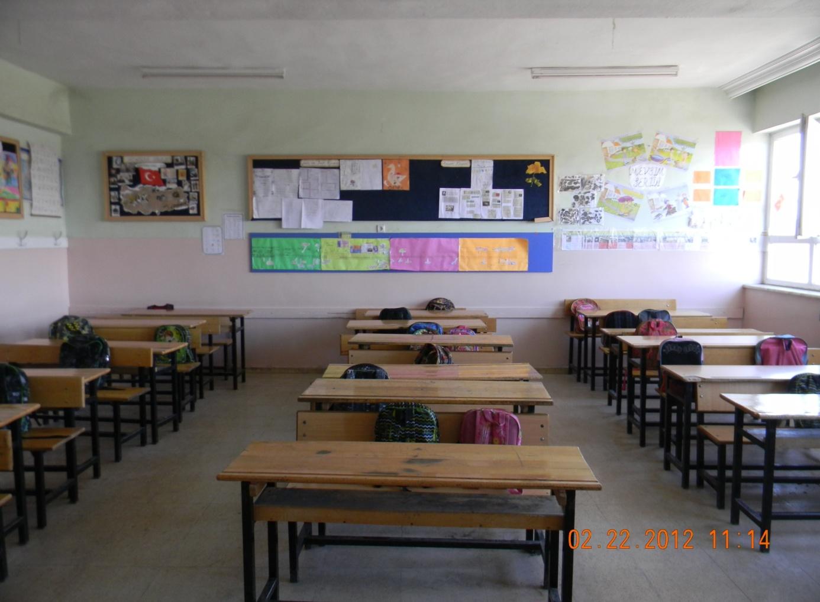

APPENDIX – 2
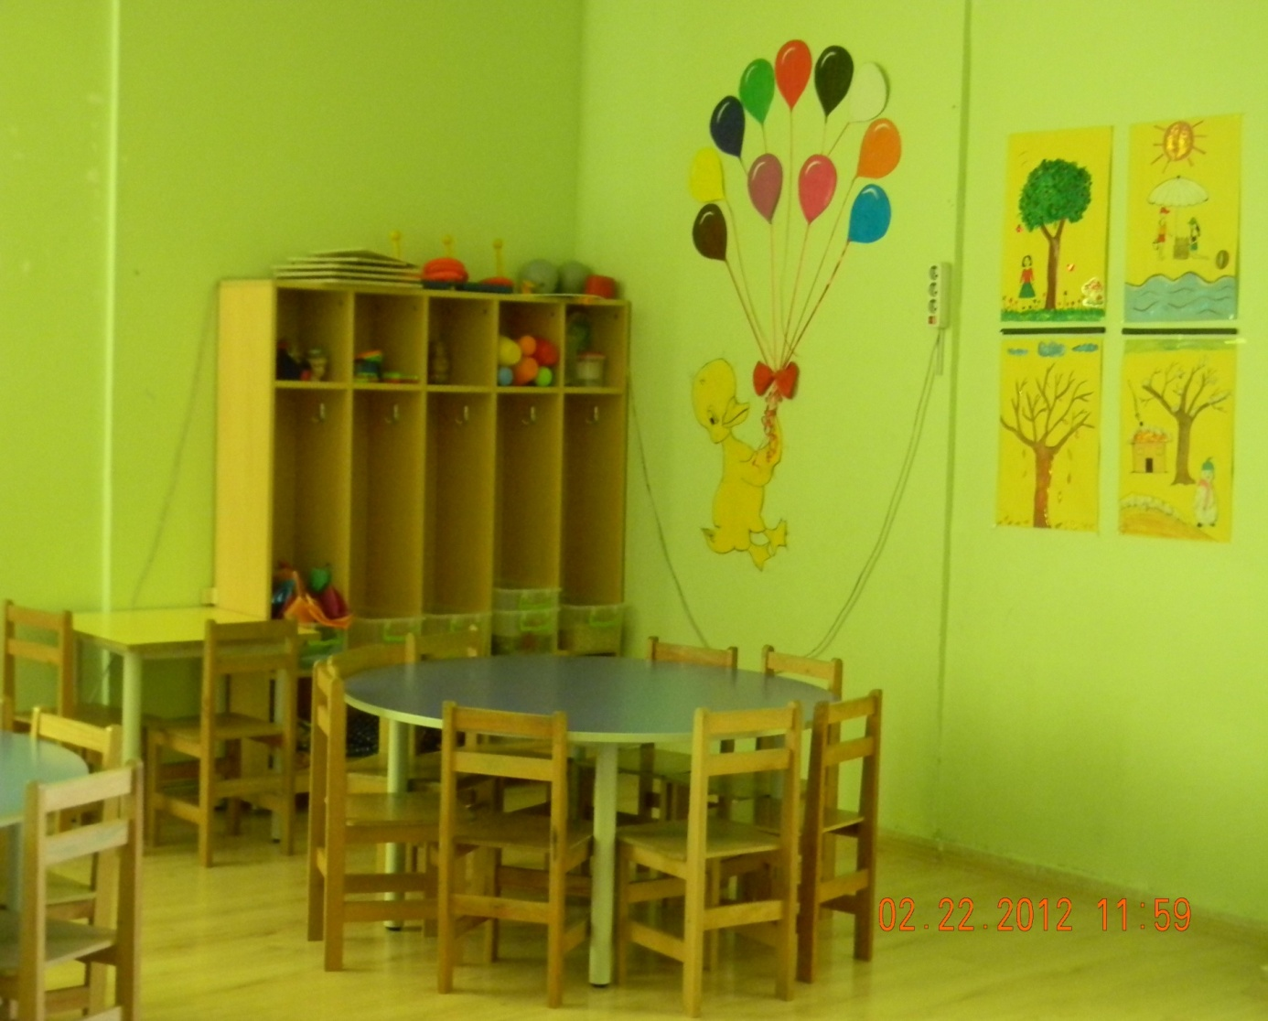

APPENDIX – 3
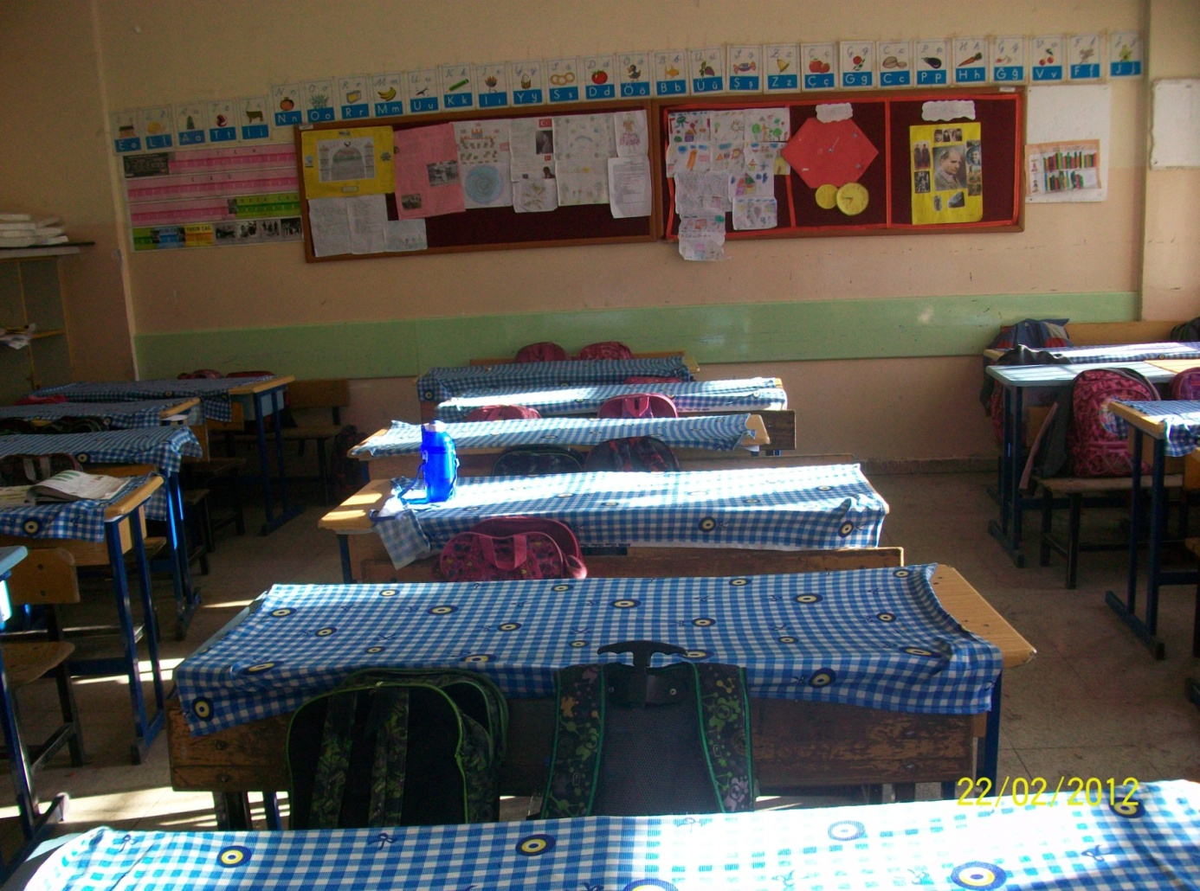

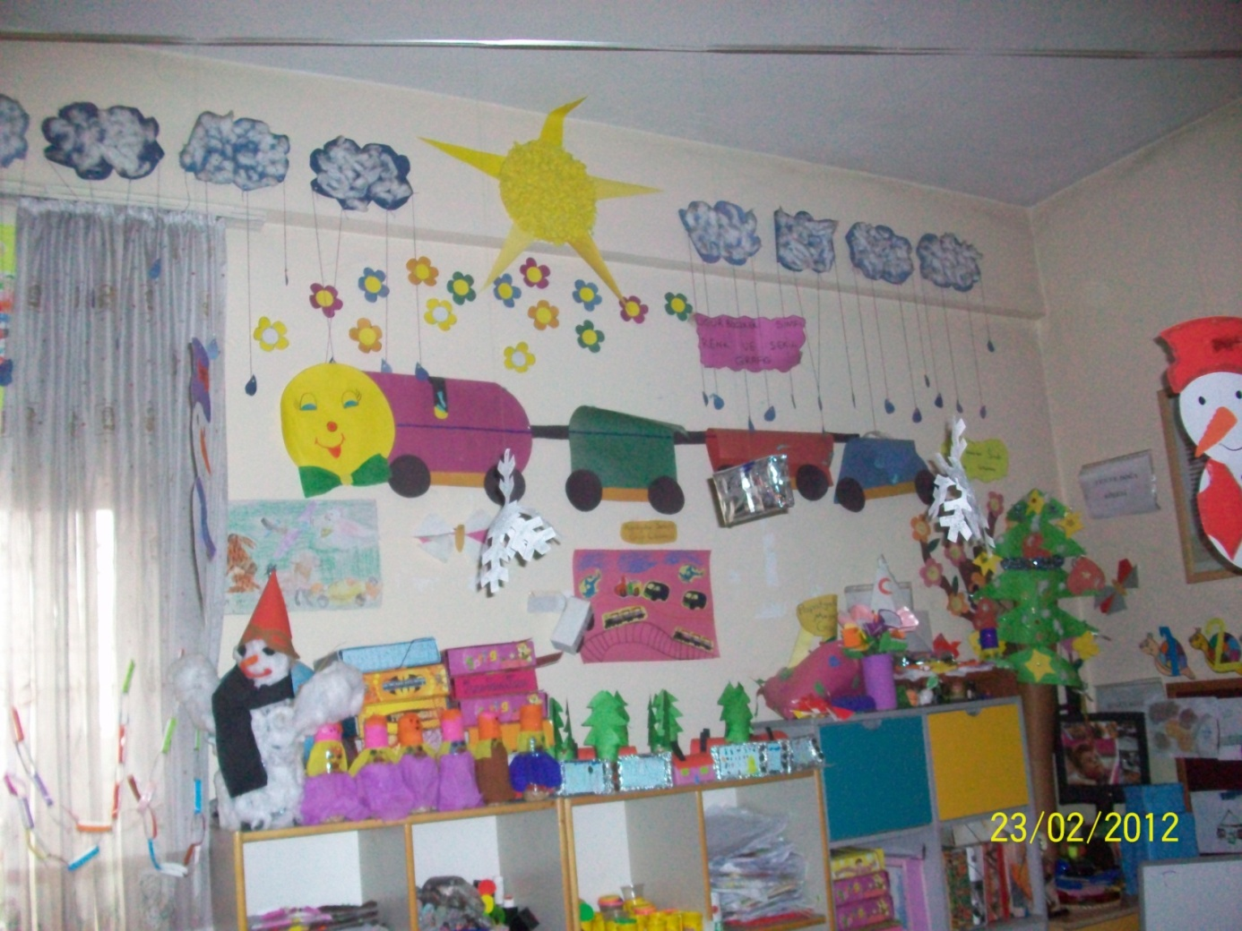
APPENDIX – 4

APPENDIX – 5
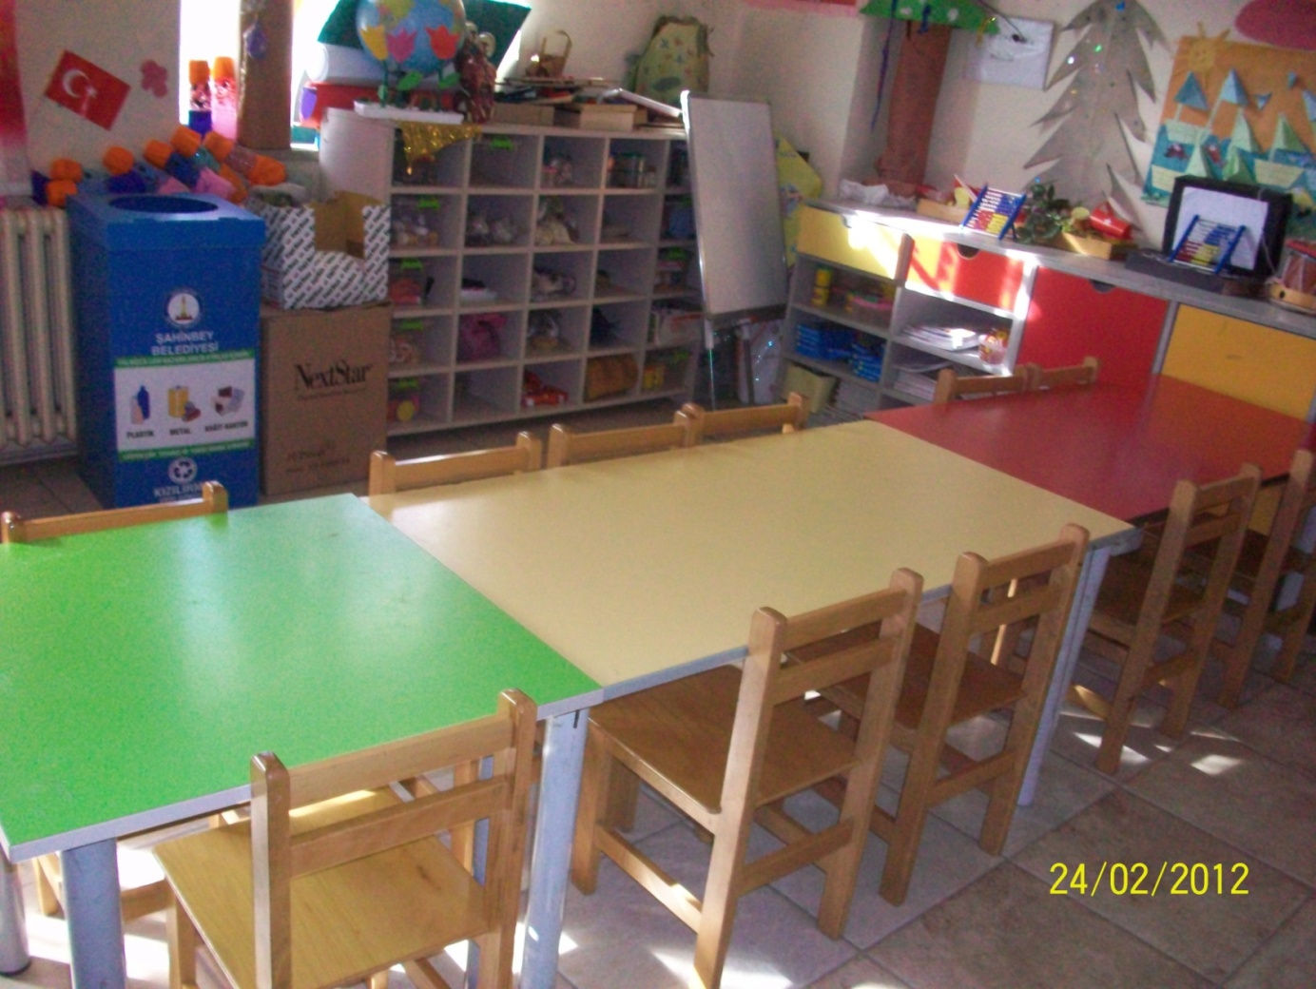

Zirve University, Institute of Social Sciences, Department of Pre-School Teaching, Ass. Prof. Dr.
Zirve University, Institute of Social Sciences, Department of Pre-School Teaching, Master Student.
Zirve University, Institute of Social Sciences, Department of Pre-School Teaching, Master Student.

